**Debugging Angular with Visual Studio Community Edition**

Well, use Chrome always

How to place a break point?

1. Click to the left of the line number



1. Shift + F9



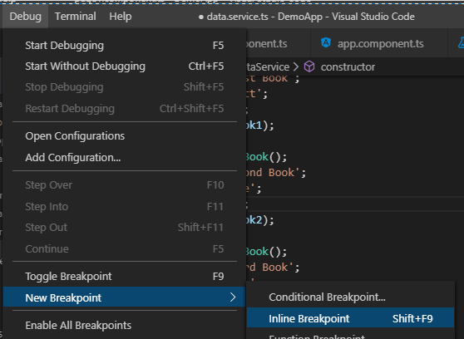

To run in Debug mode:

You need a Debug configuration:

Debug >> Open Configurations >> Chrome

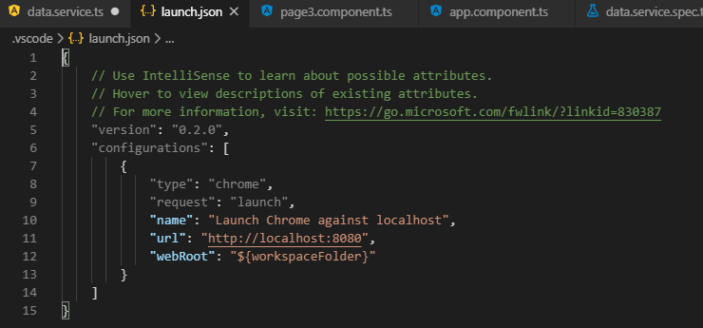

Change the 8080 to 4200 and Save Ctrl + S



Make sure the application is running

Debug >> Start Debugging

We see that stopping point is the break point

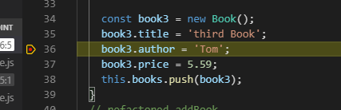

Step over, Step into …

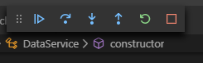

Step over

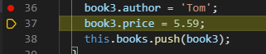

Hovering over variables reveals their values Hover over author shows Matt

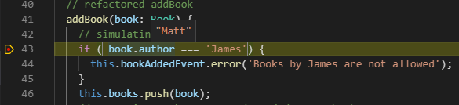

The ‘if’ should fail and step should end up at line 46 Matt ! = James

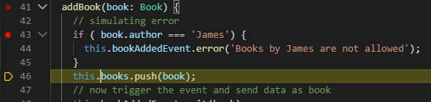

Hover over books and you can see the contents of the array

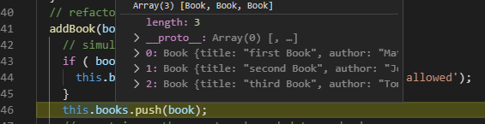

The Debug Console is live and can be typed into:

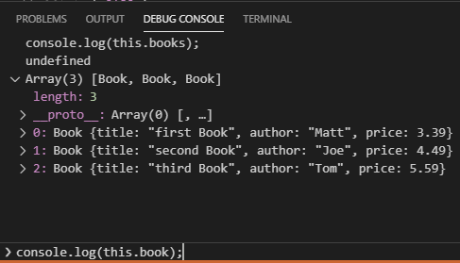

We can affect the values using the Debug Console.

Let us type a book.author = ‘Sammy’ and then hover over the code.



Enter

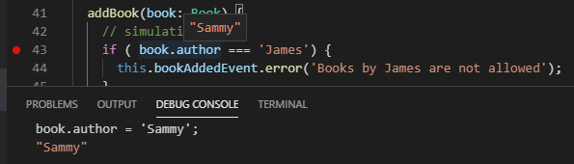

Triangle is resume, Square is exit debugging

